O’zbekiston Respublikasi Mudofaa Vazirligi

Axborot Kommunikatsiya Texnologiyalari va

Aloqa Harbiy Insituti

“Kiberxavfsizlik” fakulteti

“Tarmoq va axborot tizimlar xavfsizligi”

kafedrasi

“Python dasturlash tili”

fanidan



**Mustaqil ish**

**Bajardi:** Kursant Bobomurotov J.

**Tekshirdi:**QK xizmatchisi Sapayev Sh.

**Toshkent-2024**

1.Shaxmat doskasining x, y koordinatalari berilgan.doskaning chap pastki maydoni (1,1) qoraligi hisobga oliinib jumlani rostlikka tekshiring.

Berilgan maydon oq

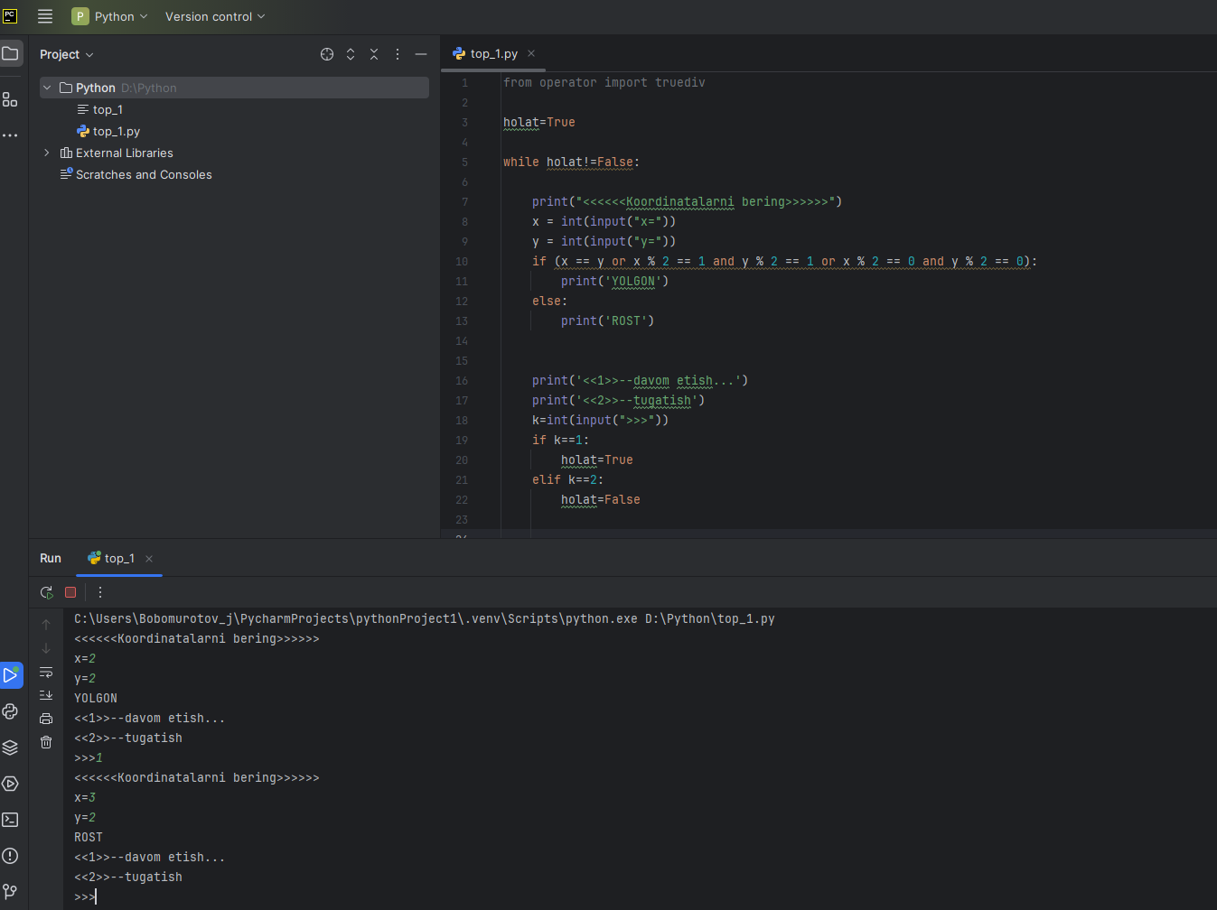

from operator import truediv

holat=True

while holat!=False:

print("<<<<<<Koordinatalarni bering>>>>>>")

x = int(input("x="))

y = int(input("y="))

if (x == y or x % 2 == 1 and y % 2 == 1 or x % 2 == 0 and y % 2 == 0):

print('YOLGON')

else:

print('ROST')

print('<<1>>--davom etish...')

print('<<2>>--tugatish')

k=int(input(">>>"))

if k==1:

holat=True

elif k==2:

holat=False

2.n butun soni berilgan n>0. Quyidagi yigindini hisoblovchi programma tuzilsin. s=n2+(n+1)2+...+(2*n)2

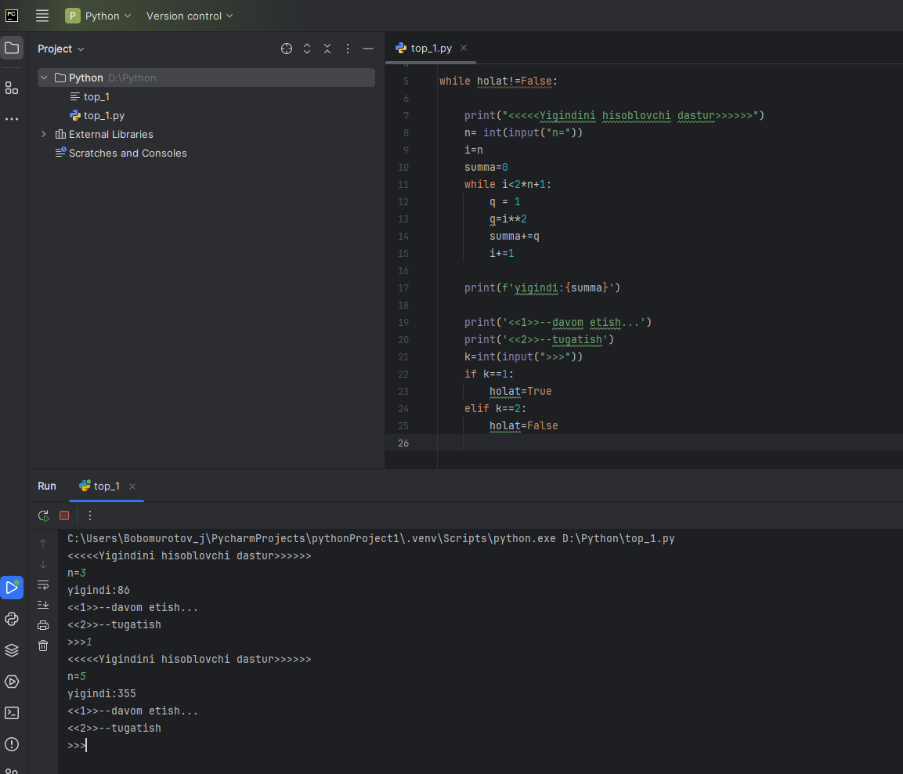

from operator import truediv

holat=True

while holat!=False:

print("<<<<<Yigindini hisoblovchi dastur>>>>>>")

n= int(input("n="))

i=n

summa=0

while i<2*n+1:

q = 1

q=i**2

summa+=q

i+=1

print(f'yigindi:{summa}')

print('<<1>>--davom etish...')

print('<<2>>--tugatish')

k=int(input(">>>"))

if k==1:

holat=True

elif k==2:

holat=False

3.Butun musbat sonni ifodalovchi ikkilik sanoq sistemasidagi son satrda berilgan.Bu sonning o'nlik sanoq sistemasidagi qiymatini ozida saqlovchi satrni chiqaruvchih programma tuzilsin

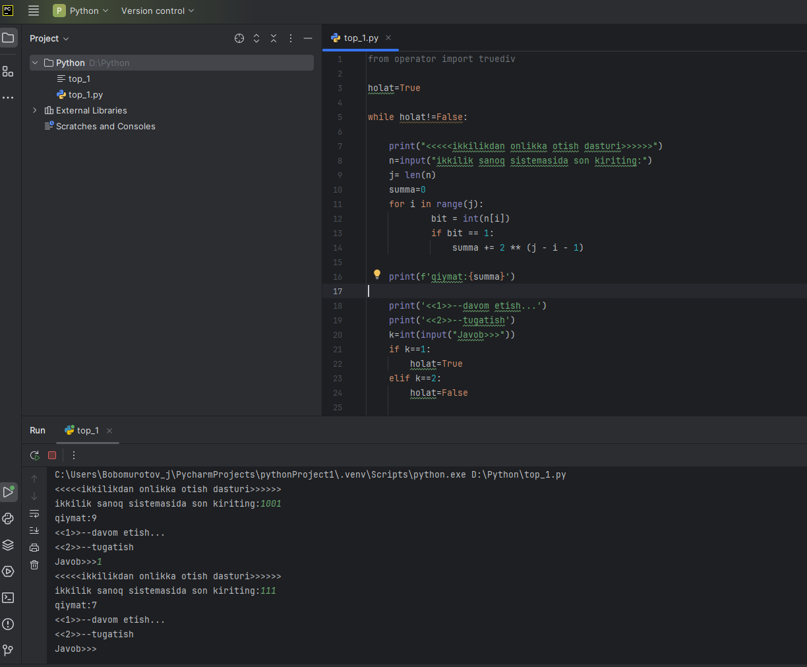

from operator import truediv

holat=True

while holat!=False:

print("<<<<<ikkilikdan onlikka otish dasturi>>>>>>")

n=input("ikkilik sanoq sistemasida son kiriting:")

j= len(n)

summa=0

for i in range(j):

bit = int(n[i])

if bit == 1:

summa += 2 ** (j - i - 1)

print(f'yigindi:{summa}')

print('<<1>>--davom etish...')

print('<<2>>--tugatish')

k=int(input(">>>"))

if k==1:

holat=True

elif k==2:

holat=False